Title

# Heading 1

## Heading 2

### Heading 3

Normal

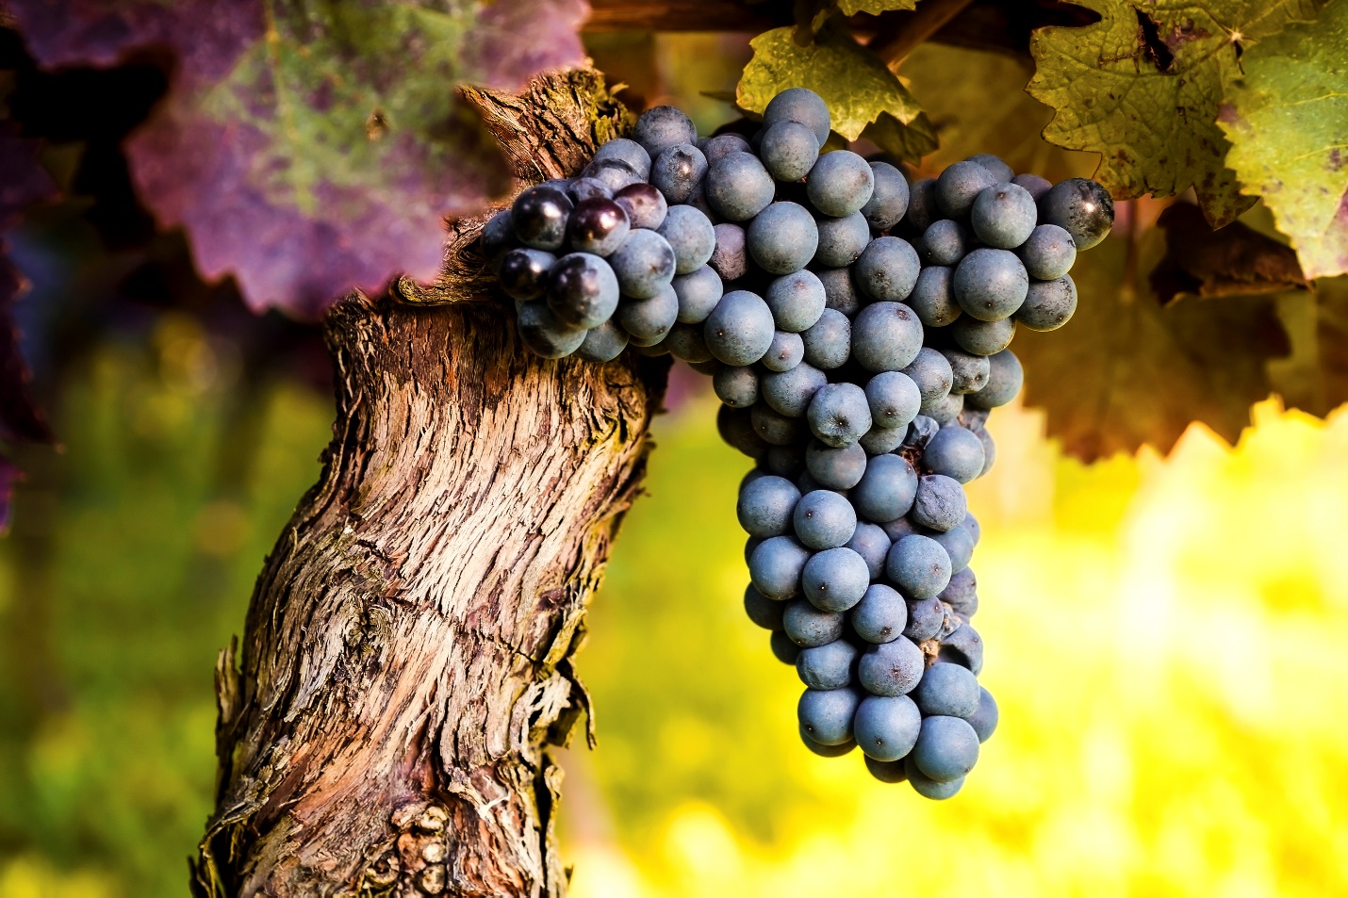

| Type of Grape | Color of Grape | Origin of Grape |
| --- | --- | --- |
| Concord | Dark purple | North America |
| Cotton candy | Green | Central California |
| Thompson seedless | Green | Persia |

[Brittanica Entry on Grapes](https://www.britannica.com/plant/grape)